Dual Board Game Console in Assembly Language

Group Members
- 24K-0961 – Muhammad Mahad Khan
- 24K-0884 – Muhammad Shahbaz Hassan
- 24K-1039 – Muhammad Samad Siddique

Submission Date
26 November 2025

1. Executive Summary

Overview
This project, Dual Board Game Console in Assembly Language, demonstrates how low-level programming concepts can be used to develop interactive applications. Two classic games Sudoku and Tic-Tac-Toe were implemented using x86 Assembly Language with the Irvine32 library. The project aims to explore data representation, memory usage, and control flow at the processor level. A user-friendly text-based interface allows players to choose a game and interact with it through keyboard input.

Key Findings
- Successfully implemented two complete console-based games in Assembly.
- Gained practical experience with low-level concepts such as registers, loops, stack handling, and memory management.
- Demonstrated that interactive logical applications can be created even without high-level abstractions.
- Created a modular system that can be extended with more games in the future.

2. Introduction

Background
Assembly Language offers unparalleled insight into how computers execute instructions. Unlike high-level languages, Assembly requires the programmer to manually manage memory, registers, loops, and I/O operations. Developing games in Assembly provides a deeper understanding of how the CPU processes data, how user input is handled at the system level, and how logical structures are implemented without built-in libraries or abstractions.
Although game development is usually done using OOP and modern languages, this project highlights how core computational concepts—such as control flow, data organization, and logic handling—can still be applied in Assembly to create functional applications.

Project Objectives
- Implement two complete games (Sudoku and Tic-Tac-Toe) in Assembly Language.
- Demonstrate mastery of registers, memory addressing, procedures, and conditional logic.
- Create an integrated menu system to allow users to choose between games.
- Handle user input and display real-time output on the console.
- Produce a well-organized, functional low-level application that reflects COAL concepts.

3. Project Description

Scope
Included in the project:
- Dual-game main menu
- Complete logic for Sudoku and Tic-Tac-Toe
- Input validation and win-condition detection
- Text-based board display
- Keyboard-based user interaction
- Modular structure for easy integration
Excluded from the project:
- GUI or graphical rendering
- Sound, animations, or advanced visual effects
- AI opponents or advanced difficulty modes
- Mouse-based interaction

Technical Overview
The project was implemented using the following tools:
- MASM (Microsoft Macro Assembler) – for assembling and linking the program
- Irvine32 Library – for console I/O operations
- Visual Studio Code – for code writing and debugging
- Windows 10 environment – required for Irvine32 compatibility

4. Methodology

Approach
The group followed an iterative development approach:
- Initial research on Assembly instructions and game logic.
- Designing flowcharts, control flow diagrams, and board representations.
- Game-wise implementation and debugging in parallel.
- Integration of both games under a unified menu system.
- Final testing and validation.
Weekly meetings were conducted to assess progress and distribute upcoming tasks.

Roles and Responsibilities
- Member 1 – Muhammad Mahad Khan (24K-0961):
Developed complete Sudoku logic, including board setup, validation.
- Member 2 – M. Shahbaz Hassan (24K-0884):
Handled the menu design, user interface, board printing, game integration, and overall I/O structure (including WASD navigation).
- Member 3 – M. Samad Siddique (24K-1039):
Implemented Filing and move validation for Tic Tac Toe and Sudoku along with Tic-Tac-Toe game logic, win checking, and input validation.

5. Project Implementation

Design and Structure
The project consists of three main modules:
- Menu Module:
Displays game options and redirects the user to the selected module.
- Sudoku Module:
  - Predefined puzzle stored in memory
  - Logic for input, validation, and correctness checking
  - Board display using loops and formatted printing
- Tic-Tac-Toe Module:
  - 3×3 board stored in memory
  - Player X and O turn handling
  - Win/Draw detection through row, column, and diagonal checks
Memory layouts were carefully planned using arrays, byte buffers, and labels.

Functionalities Developed
- Interactive menu with numeric key selection
- Sudoku board display and move validation
- Detection of invalid moves or repeating numbers
- Tic-Tac-Toe board updates after each move
- Real-time win/draw announcements
- Well-structured procedures for printing, input, and board updates

Challenges Faced
- Handling multi-digit input in Sudoku required custom routines.
- Managing memory and registers without interfering with other modules.
- Ensuring no infinite loops occurred during invalid input cases.
- Debugging in Assembly was more time-consuming due to low-level execution flow.
All issues were resolved through step-by-step tracing and register monitoring in the debugger.

6. Results

Project Outcomes
- Fully functional dual-game console built entirely in Assembly Language.
- Menu-driven interface providing seamless navigation between games.
- Logical correctness validated for both Sudoku and Tic-Tac-Toe.
- Project objectives fully achieved.

Screenshots and Illustrations
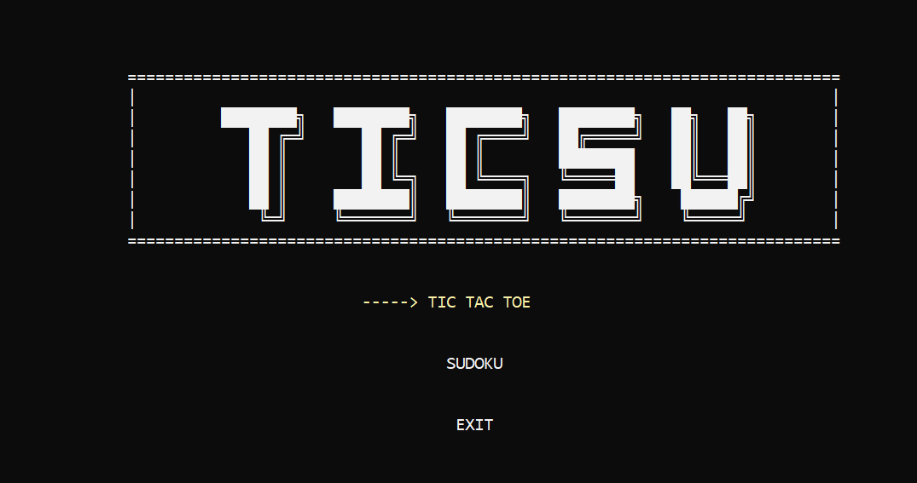
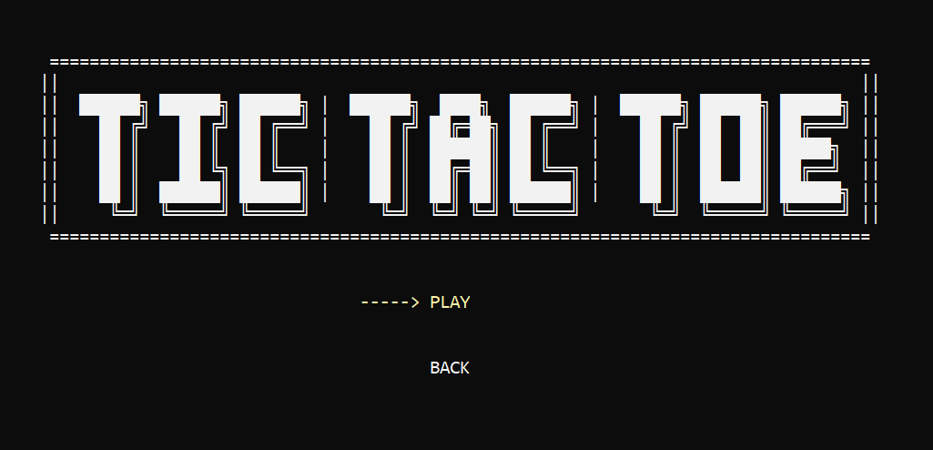
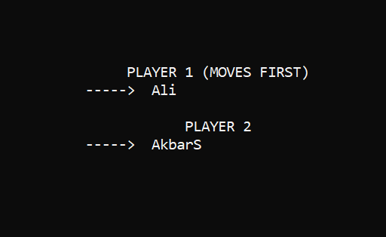
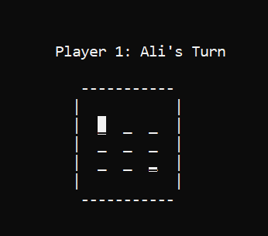
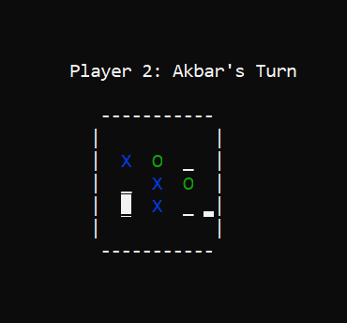
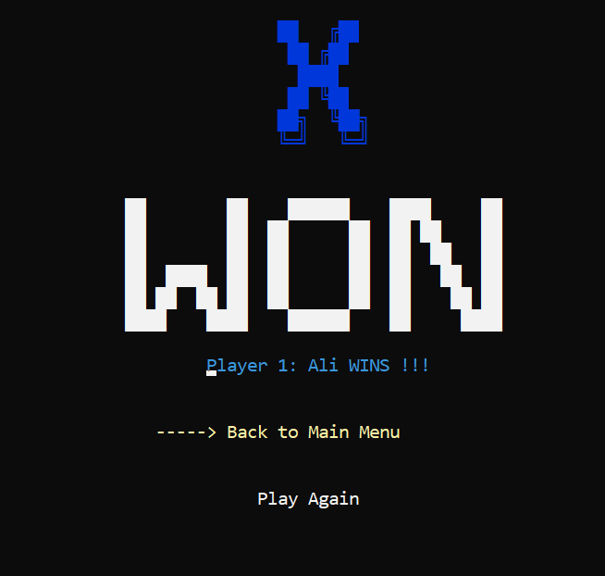
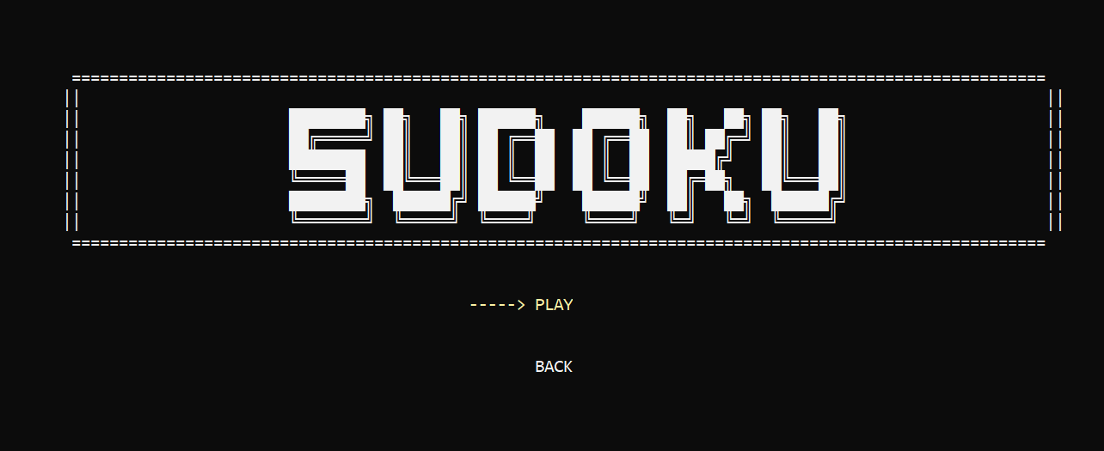
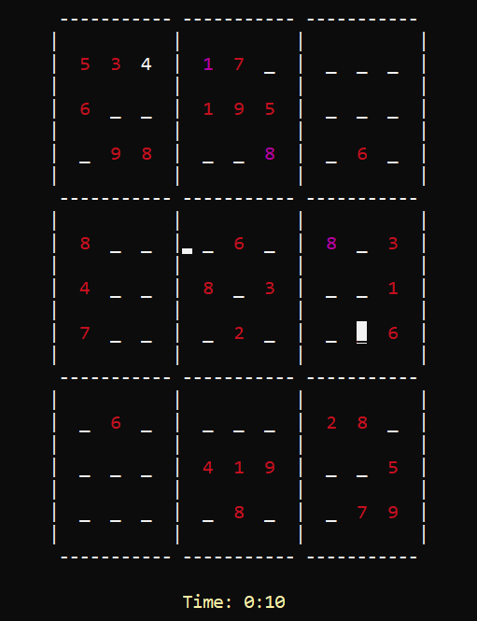
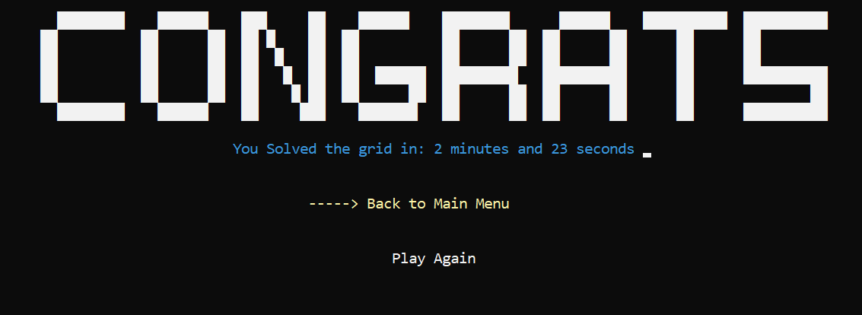
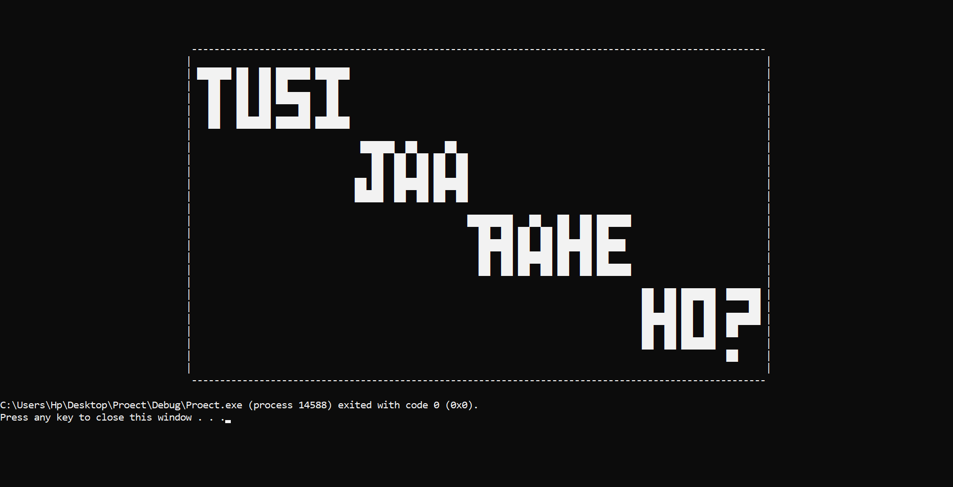

Testing and Validation
Testing was performed using:
- Multiple Sudoku input cases
- Repeated Tic-Tac-Toe sessions to check all win possibilities
- Validation of invalid input handling
- Integration tests ensuring switching between games works without errors
All test cases passed successfully.

7. Conclusion

Summary of Findings
The project successfully demonstrates the ability to build functional, interactive applications using Assembly Language. By implementing Sudoku and Tic-Tac-Toe, the group gained practical experience in memory management, register-level control flow, and low-level I/O handling. The system addresses the challenge of developing logic-based programs without high-level support.

Final Remarks
This project strengthened the group’s understanding of core COAL concepts and highlighted the importance of algorithmic thinking even at the lowest programming levels. The modular structure can support additional games in the future, and the experience gained serves as a strong foundation for future low-level and system programming tasks.

